Across the town Příbram
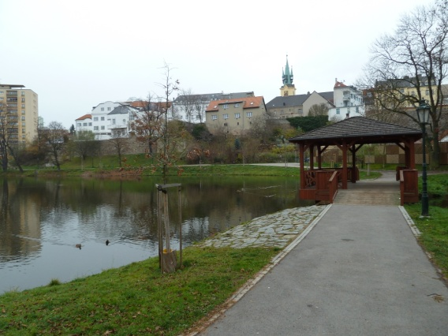
General information:
Příbram is a city located in region, approximately km from the capital Prague, at the foot of mountain range, the river flows through the city. .

History:
The first mentioning about Příbram comes from the year .
At the end of century was mined here.
During the reign of Karla IV the archbishop lived here. .
The archbishop gave Příbram rights town in the year . .

First stop:
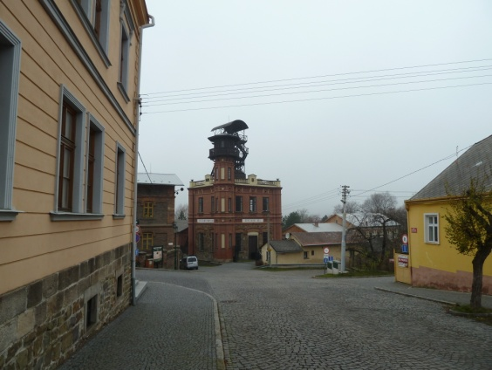
Březové Hory
The village Březové Hory joined Příbram in 1953. Příbram used to be a well-known mining city. This fact commemorates the museum of Příbram.
Try to find out as much information as possible:
When was mining started?
How many shafts were here?
What are the names of the shafts now?
There was a big fire in one of the shafts, which of them was it? In which year did it happen? How many miners were killed by the fire?
Which parts does the mining museum consist of?
Besides the museum, there are three churches in Březové Hory. Find them and take a photo of them.

Second stop:
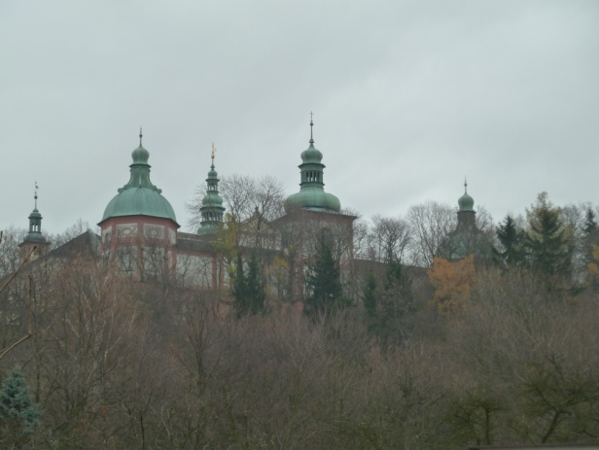
The holy mountain
Which architectonic style was it built in?
When was it built?
Who is the owner of the cathedral nowadays? Which Church?
When was the building destroyed by a fire?
Find out a story about it and paint a picture of the story.
How can you get to the Holy Mountain? Find two possible ways and draw them in the city plan.

Third stop:
Square of TGM
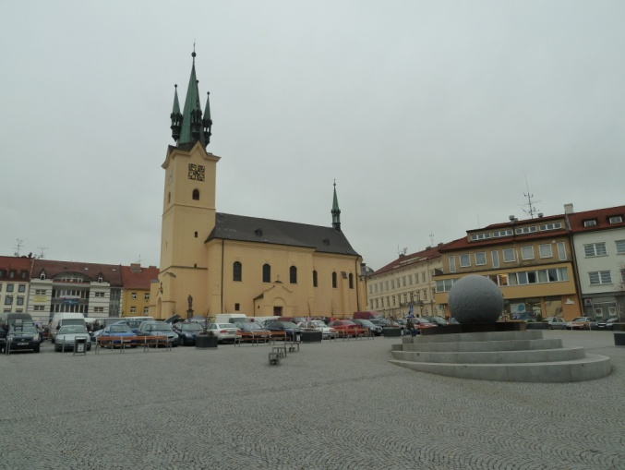
Who was TGM? When did he visit Příbram?
Which sights are located in the square?
When of the church of St. Jacob founded?
Find a house sgraffiti made according the drawings of Mikoláš Aleš! Which topic do they have?
Find out the opening hours in the town library of Jan Drda. Who was he?
Who was the municipal building built by and when?
What is Ernestinum and what can you find inside?
Find some interesting landmarks in Prague Street and Jiráskovy sady and take a photo of it.
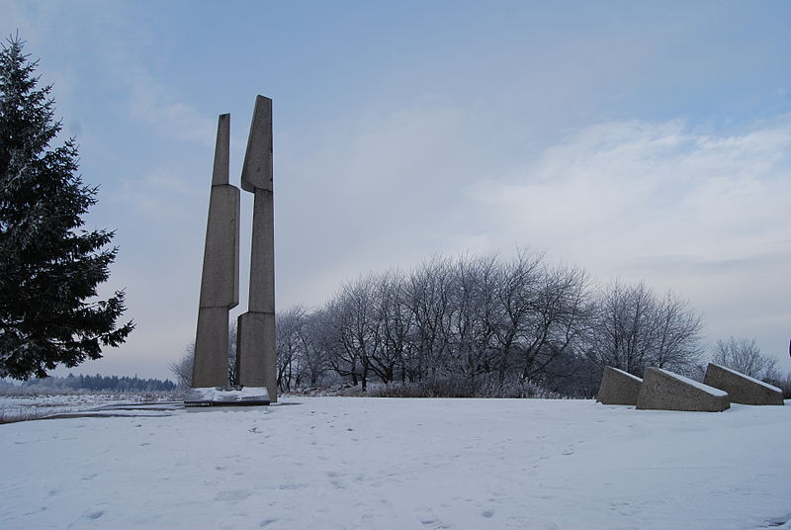
Fourth stop:
Slivice:
During the Second World War, there were strong secret groups of soldiers, who tried to fight against the Germans. People say that in the nearby village Slivice the last shooting of the Second World War took place. A memorial commemorates that.
What is organised here every year and when exactly?
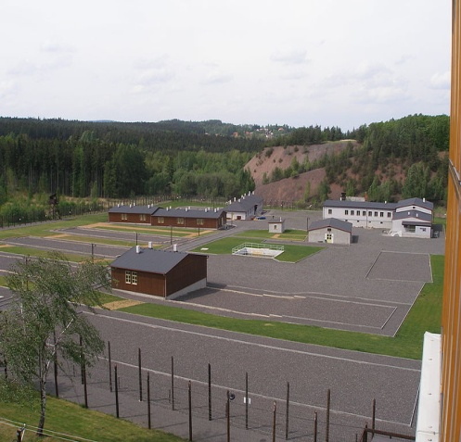

Fifth stop:
Vojna:
A sad story from our history, in 1950, local mines were a part of work camps. Take a walk to the memorial called Vojna in Lešetice and find out some information about local prisoners. What were their jobs? How did it work in the camp? How did you feel there?
Write a short text about it?

Sources:
http://cs.wikipedia.org/wiki/
http://www.tenisova-skola.cz/hornicke-muzeum-pribram.html.
http://upload.wikimedia.org/wikipedia/commons/9/9b/Pam%C3%A1tn%C3%ADk_Mil%C3%ADn_(2).jpg

